Daniel Fryer
Assignment 2.2 Debug
1/21/2026
Start of the debugger
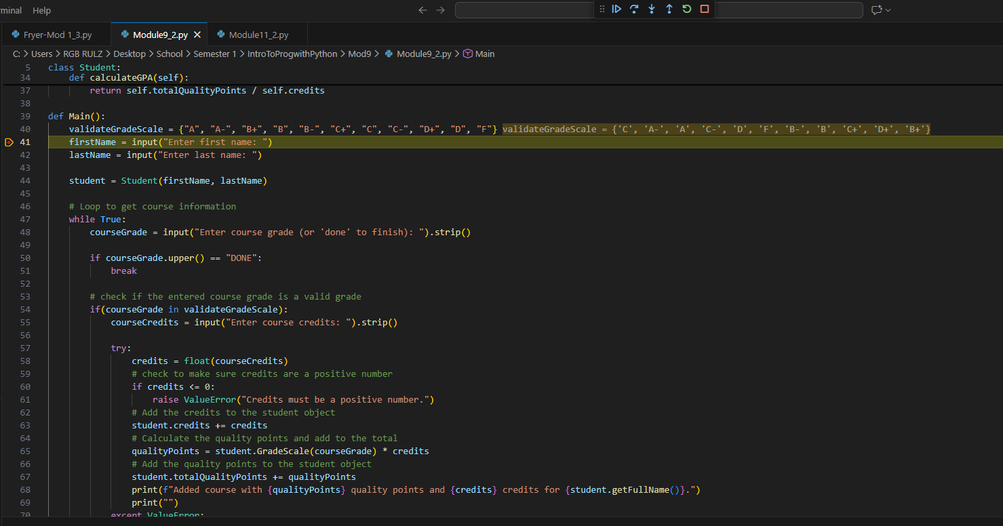
Stepped into the next line
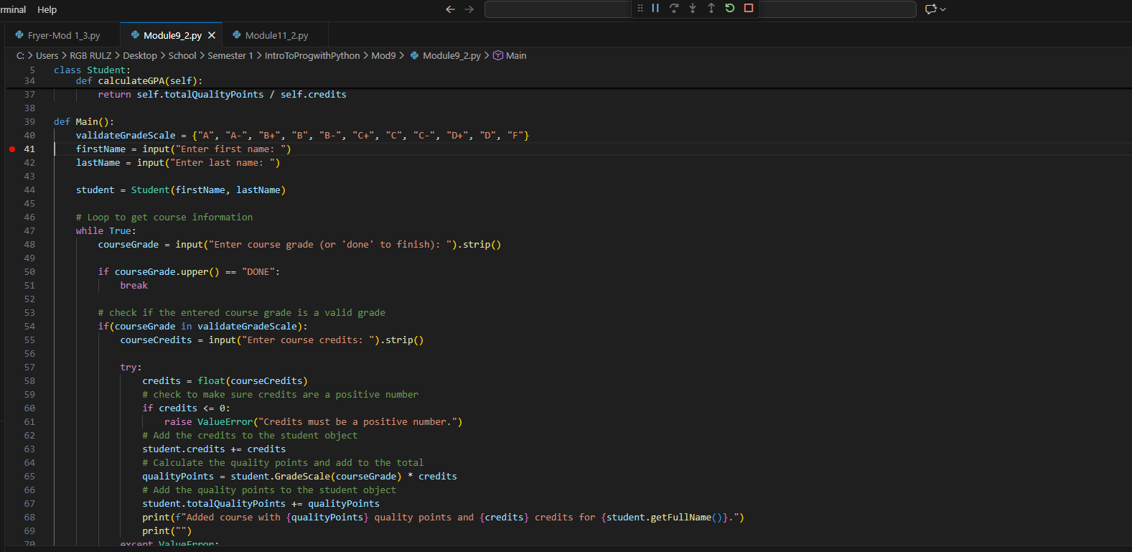
Error happened
